Laboratoriya ishi – 10
Mavzu : CSS transition va animatsiya elementlarini yaratish
Ishning maqsadi - Ushbu ishning asosiy maqsadi — veb-sahifalarda elementlarning harakatini silliq va ko‘zni quvontiradigan ko‘rinishda amalga oshirish uchun CSS transition va CSS animatsiya xususiyatlaridan foydalanishni o‘rganishdir.
Talaba quyidagilarni o‘rganadi:
- CSS transition yordamida elementlarning holatini silliq o‘zgartirish
- CSS animatsiya orqali murakkab harakatlar yaratish
- @keyframes yordamida animatsiya bosqichlarini belgilash
- Foydalanuvchi bilan interaktivlikni oshirish

Nazariy qism

1. CSS Transition nima?
CSS Transition — elementning bir holatdan ikkinchi holatga o‘tishini silliq (asta-sekin) bajarishga imkon beradi. Masalan, tugma ustiga sichqoncha olib borilganda (hover) uning rangi, o‘lchami yoki joylashuvi sekin o‘zgaradi.
Asosiy xossalari:
- transition-property – qaysi xossa o‘zgarishini belgilaydi
- transition-duration – o‘tish davomiyligi
- transition-timing-function – o‘tish tezligini boshqaradi
- transition-delay – kechikishini belgilaydi
Misol:
button {
background: blue;
transition: background 0.5s ease;
}

button:hover {
background: red;
}
Natija: Tugma ustiga borganda rangi 0.5 soniyada silliq qizil rangga o‘zgaradi
2. CSS Animation nima?
CSS Animation esa murakkabroq harakatlarni yaratish uchun ishlatiladi. Bunda harakat bosqichlari @keyframes orqali belgilanadi.
Asosiy xossalari:
- animation-name – animatsiya nomi
- animation-duration – davom etish vaqti
- animation-iteration-count – necha marta takrorlanishi
- animation-direction – yo‘nalishi
- animation-timing-function – tezlik rejimi
Misol:
.box {
width: 100px;
height: 100px;
background: green;
animation: move 2s infinite;
}

@keyframes move {
0% { transform: translateX(0); }
50% { transform: translateX(200px); }
100% { transform: translateX(0); }
}
Natija: Yashil kvadrat ekranda oldinga va orqaga harakatlanadi.
Laboratoriya ishining bajarilishi
CSS transition va animatsiya elementlarini yaratish shu mavzuda O`zbеk milliy taоmlari хaQida veb sahifa yaratish html kodida .
Kod:
<!DOCTYPE html>
<html lang="uz">
<head>
<meta charset="UTF-8">
<title>O'zbek milliy taomlari</title>

<style>
body{
margin:0;
font-family: Arial, sans-serif;
background:#f6efe2;
}

/* ===== Sarlavha ===== */
header{
background:#7a0000;
color:white;
padding:25px;
text-align:center;
animation: titleGlow 2s infinite alternate;
}

@keyframes titleGlow{
from{letter-spacing:2px;}
to{letter-spacing:6px;}
}

/* ===== Asosiy qism ===== */
.container{
display:flex;
justify-content:center;
flex-wrap:wrap;
gap:25px;
padding:40px;
}

/* ===== Kartalar ===== */
.card{
width:260px;
background:white;
border-radius:15px;
overflow:hidden;
transition: 0.5s;
box-shadow:0 5px 15px rgba(0,0,0,0.2);
}

/* Transition effekti */
.card:hover{
transform: scale(1.08);
box-shadow:0 10px 25px rgba(0,0,0,0.4);
}

.card img{
width:100%;
height:180px;
object-fit:cover;
}

.card-content{
padding:15px;
text-align:center;
}

.card h3{
color:#7a0000;
}

/* ===== Tugma ===== */
.btn{
display:inline-block;
padding:8px 20px;
background:#7a0000;
color:white;
text-decoration:none;
border-radius:20px;
margin-top:10px;
transition:0.5s;
}

.btn:hover{
background:#b22222;
transform: translateY(-5px);
}

/* ===== Harakatlanuvchi matn ===== */
.moving-text{
text-align:center;
font-size:22px;
color:green;
margin-top:15px;
animation: move 6s infinite linear;
}

@keyframes move{
0%{transform:translateX(-150px)}
50%{transform:translateX(150px)}
100%{transform:translateX(-150px)}
}

footer{
text-align:center;
background:#7a0000;
color:white;
padding:12px;
margin-top:20px;
}

</style>
</head>

<body>

<header>
<h1>O'zbek Milliy Taomlari</h1>
<p>CSS Transition va Animatsiya asosida yaratilgan sahifa</p>
</header>

<div class="moving-text">
🍽 Milliy taomlarimiz – millatimiz faxri!
</div>

<div class="container">

<!-- Osh -->
<div class="card">
<img src="https://i.imgur.com/6RL9FJk.jpg">
<div class="card-content">
<h3>Osh (Palov)</h3>
<p>Guruch, sabzi va go‘shtdan tayyorlanadigan eng mashhur o‘zbek taomi.</p>
<a href="#" class="btn">Batafsil</a>
</div>
</div>

<!-- Somsa -->
<div class="card">
<img src="https://i.imgur.com/7dEK4N6.jpg">
<div class="card-content">
<h3>Somsa</h3>
<p>Qarsildoq xamir va go‘shtli ichlik bilan pishiriladi.</p>
<a href="#" class="btn">Batafsil</a>
</div>
</div>

<!-- Lag'mon -->
<div class="card">
<img src="https://i.imgur.com/2q3Z2kY.jpg">
<div class="card-content">
<h3>Lag‘mon</h3>
<p>Maxsus cho‘zilgan makaron va sousli taom.</p>
<a href="#" class="btn">Batafsil</a>
</div>
</div>

<!-- Shashlik -->
<div class="card">
<img src="https://i.imgur.com/V0GQ2zK.jpg">
<div class="card-content">
<h3>Shashlik</h3>
<p>Ko‘mirda qovurilgan mazali go‘sht bo‘laklari.</p>
<a href="#" class="btn">Batafsil</a>
</div>
</div>

</div>

<footer>
<p>© 2025 | CSS Transition & Animation – O‘zbek milliy taomlari</p>
</footer>

</body>
</html>

Natija:
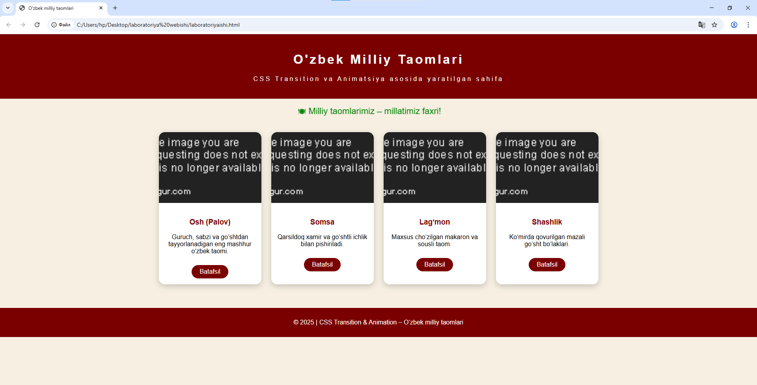
Xulosa
Ushbu amaliy ish jarayonida CSS transition va CSS animatsiya texnologiyalaridan foydalanib, “O‘zbek milliy taomlari” mavzusida dinamik va interaktiv veb-sahifa yaratildi. Sahifada joylashtirilgan kartalar, tugmalar va harakatlanuvchi matnlar foydalanuvchi e’tiborini jalb qiladigan ko‘rinishga ega bo‘ldi. Transition yordamida karta va tugmalarning ustiga sichqoncha olib borilganda ularning rangi, o‘lchami va joylashuvi silliq o‘zgaradi. Bu esa sahifani yanada qulay va jozibador ko‘rsatadi. Animation yordamida esa sarlavha va matnlarga doimiy harakat berilib, sahifaga jonlilik va zamonaviylik baxsh etildi.
Mazkur ish orqali CSS transition va animatsiyaning amaliy qo‘llanilishi, ularning farqi va afzalliklari o‘zlashtirildi. Natijada esa foydalanuvchi uchun qulay, chiroyli va zamonaviy veb interfeys yaratish mumkinligi isbotlandi.

